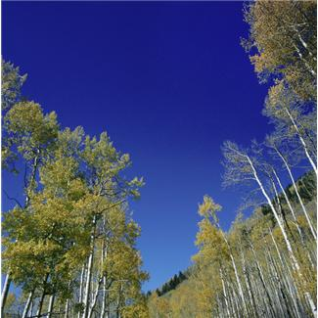

Festive Christmas Walk in the Cong Woods

You are invited to come on a leisurely walk in cong woods on Sunday next December 5th. Everyone is welcome; walkers, Fit4lifers, outdoor enthusiasts and families are all welcome. The pace will be leisurely and will suit all walkers. Opportunity to try Nordic Walking also during the walk!!!

Meeting outside O’ Connors Supermarket at 11am.

Tea and Chat afterwards.

Contact Fit4life leaders Mary 087 7632838, Colette 087 6470885 or P.J. 085 1742816

