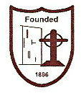
Balla GAA Bord na nÓg

In conjunction with
FIT4LIFE
Mayo Sports Partnership
and

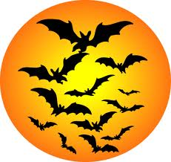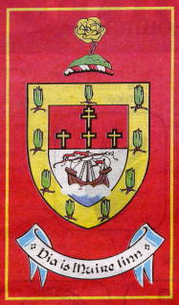

Hallowe’en 5km Fun Run/Walk
(Hallowe’en Costumes Optional)
Sunday 24th October, 2010
Time: 2pm
Starting Point: The Square, Balla
Entries taken on the day at The Dock Youth Centre from 1pm
Entries: €10 per person
Family: €20
Spots/Prizes for the best original costumes

